|  |  |  |  |  |  |  |  |  |  |  |  |  |  |
| --- | --- | --- | --- | --- | --- | --- | --- | --- | --- | --- | --- | --- | --- |
| KblPfbt3 ptl('Iy6JIHI{ACbr | | |  |  |  |  |  | IGIPTbBCKA'PECIIYFNI4KA | | | | |  |
| BI4IIKIM BEPYY XAI]A I4IIVM MUIfLICTPIII4I'U | | | |  |  |  |  |  |
| xAJrAJr_AbAA | | OEJrACT.br |  |  |  |  |  | MHHI4CTEPCTBO O6PA3OBAHI4JI H HAYKI4 | | | | |  |
| AJIA-EYKA PAI1OHAYK | | |  |  |  |  |  | XAJrAIr_AEAACKA' OEJTACTb | | | | |  |
| EI4JII4M 6EPYY BOJIYMY | | |  |  |  |  |  | AJI A-E YKI4HCKUfr PAIZOHHbIff | | | | |  |
|  |  |  |  |  | OTAEJI OEPA3OBAHI4' | | | | |  |
|  |  |  |  |  |  |  |  |  |
| 7 207 00, A,ra-Byrca afi ",n" I46pffiii! | | |  |  |  |  |  |  | 720700, | | c.Ana-Eyr<a | |  |
| Ter. +996 (0-3741) 5-04-16.5-04-15 | | |  |  |  |  |  |  |  |  |  |
| Qarc: +996 (0-3i41 5-04- I 6 | |  |  |  |  |  |  | yn. H6paranrona, T4al.abukargo@mail nt | | | | |  |
| ?91 8- xrrJrAbrH " 4 i*-,, corr*, z[l/,7 | | | |  |  |  |  |  |  |  |  |  |  |
| Ns. Ba^ps k-rg | | |  |  |  |  |  |  |  |  |  |  |  |
|  |  |  |  | Xa,r a.rr -A 6a g oG nacrrbr K ycyJrAyK | | | | | | | |  |  |
|  |  |  |  | dwnwrw 6epyy 6op6opyHa | | | | |  |  |  |  |  |
|  | A.na-Eyrca pafroHAyK 6urnM 6epyy do.nyvryne KaparuTyy Nb39 Afiprr- | | | | | | | | | | | |  |
| Tam ruru'a3uqcbr6oroHqa reMoHAoryaoii *aurr"r*ar 6epe6'3: | | | | | | | | | |  |  |  |  |
|  | Ana-Fyxa | _ paffouyna Kaparuryy l-Mafi ail,;rtr uftru."rn"r" Afip'-Tarvr | | | | | | | | | | |  |
|  |  |  |  |  |  |  |  |  |  |  |  |  |
| afrrr*rura Nb19 | | M.Anrru6eron arbrHAar.br )KaJrrrbr opro luturvr6epyy.ry uexre6u, | | | | | | | | | | |  |
| J\1b39 |  |  |
| Afiprr-Tavr rIrMI{a3I4t uerre6a >xafiraurxan. l-Mafi aftru4rrx Ker{e,,,u | | | | | | | | | | | |  |
|  |  |
| 2018-xrrnlr'rn3-Ntaffr,rurAarbl orypyMvr.rflaooNslg M.A6rv6er<oe arbrHAarbr | | | | | | | | | | | | |  |
| xaJInbI opro 6wwrw 6epyyvy vexre6aue Ns39 Afiprr-TaM rr,rMHasu.f, N,rercre6zFr | | | | | | | | | | | | |  |
| crarycyH caKTarr Kanyy xony MerrgFr | | | | | 6lrprarcraply xoHyHAOry,, MaceJre KapanfaH | | | | | | | |  |
| )KaHa ToKToMy | | r{bu'apr'}InraH. | |  |  |
| xaHa Afiprr-TaN'rrT4w1a3krfl | | | EupzKTI4pyyHyH Herr43fu ce1e6u. M.Anul,r6eron | | | | | | | | | |  |
| MeKTenrepr4 )KaKbrH xafiraruxaHAbrrbr xaHa xblg | | | | | | | | | |  |
|  |  |  |  |
| M.Anrrira6eKoB arbrHAarbr opro naerre6nsre 4 rlaccrhrK xa6uuer 6oru exeu ALrrLr, | | | | | | | | | | | | |  |
| N39 Afipr'r-TaMrI'IMrIa3I4f,MeKTe6u aaapurnbrK MeKTerr (oKM HbrH lreqvuu Nor) | | | | | | | | | | | | |  |
| Aer afrfttrtraH'6npor, i\b39 Ailpr,r-rav ruMHa3r4fl uexre6u aBapufl,nbrx a1atila | | | | | | | | | | | | |  |
| 3Mec SKeH/'larI4)KaHa KPnuH Kapxu l\ittlHacrpJr vrrLr rapa6rrHaH Karrr4TaJIAbrK . | | | | | | | | | | | | |  |
| peMoHTToro "20l9-xlt-u4rrn 6roAxerl4He Kapa[rrbrpyy ]r(oHyHAo,, Karbl KeJrreH. | | | | | | | | | | | | |  |
| Eyn n'racele6orcu'rapafiouAyr< 6unura 6epyy 6ony^ay ara-sHeJrep, MeKren | | | | | | | | | | | | |  |
| xaMaarbl 'aitsttr oKM'TYHYHoKYnqynyl(ropy MeHeH 6rup.eruunre 3 xory xrrfir*r | | | | | | | | | | | | |  |
| orl{oproH'xrrftrrH/Ia ara-3Hdnep J\b39 Aiiprr-TaM ruMHa3r,rr MeKTe6uu caxran | | | | | | | | | | | | |  |
| Kanyy xarblH cyparlbllllKaH xaHa peMoltl']'o | | | | | | |  |  |  |  |  |  |  |
|  |  |  |  |  |  | HIxrepI4H yuyn xbrJrfa .refizH ara- | | | | | | |  |
| 3HenepAI4H xap/IaMblH/{a arKapbll] KeJIHTIII(eHaH afirltrunun *u"u rr4MHa3lrf,HbrH | | | | | | | | | | | | |  |
| xo6ocyna rrrafir*'rHMH€r3r4s | | | uexre6r4lre oKyr{ynapAbr raHAoo y.ryH xaKbrHKbr | | | | | | | | | |  |
| apanblKra MeKrerlrep Solyruy KepeK. lenu vrext..rr, 6r,rpuxrrapyy | | | | | | | | | | 6oron qa ara- | | |  |
| 3HeJrep'MeK'ferrxaMaarbr Kaprubrnbrrrru 6nr4r,rpzruxeu) | | | | | | | | | r r |  |
| J\b39 Afiprr-T'avrurMHa3r4fl | | | |  |  | Krrprrr: | | pecnyonzKacbrHbrH | | | |  |  |
| uex't'e6n | | |  | Eunuu |  |
| 6epYY x{aHa ulruM MHHacrpJIurvHuH | | | | |  |  |  |  |  |  |  |  |
| anAbrHAarbr 6wmvr 6epyy MeKeMenepr.rH | | | | | | | |  |
| JII{IIeH3I'I'JIOO | |  |  |  |  |
|  | XaHa aKl(peAr4Tarlr4.rrJroo 6orcH.ra | | | | | | MaulererrrrK'rnrrranqr4{cblHbrH | | | | | |  |
| 2013-xrur,&r,rH l6-aexadpbrHAarbr | | | | j\e547lr | | 6yftpyryuyu Herr43r.rHAe K'p*r: | | | | | | |  |

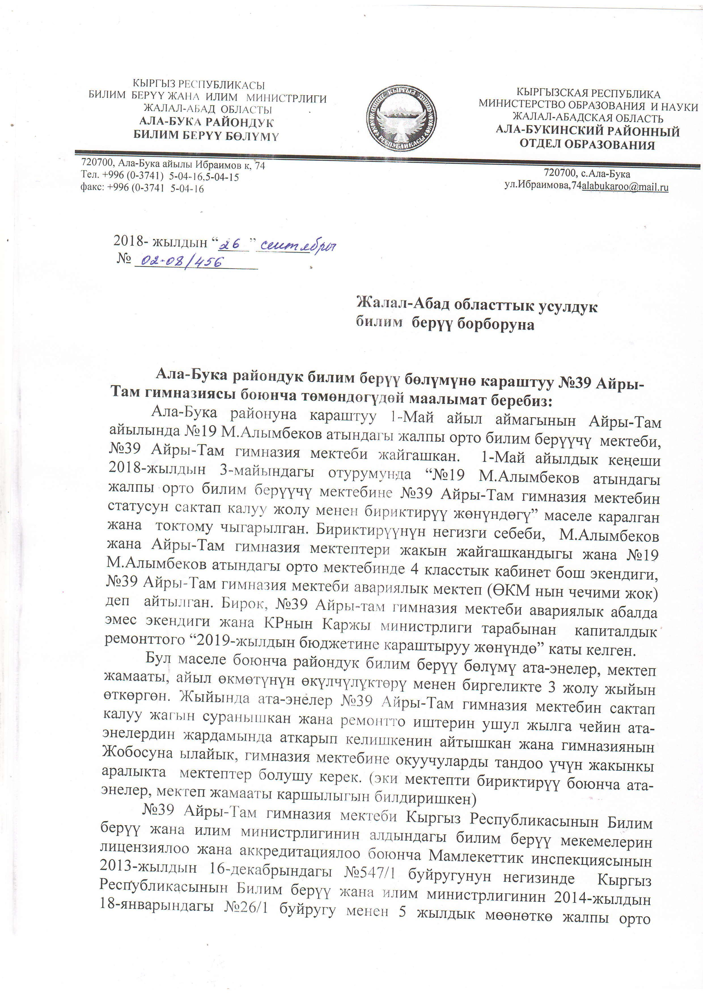Pecrfy6nHKacbIHbIH Fl"rrara 6epyy xar{a r4truM Mr4Hr4crpnr4rr4Hr,rH z;l4-xsrrAbrH l8-runapuHAarbl J\e26ll oyrpyry Mer{eH 5 xbrnAbrK MooHerKo )K€urnbr opro

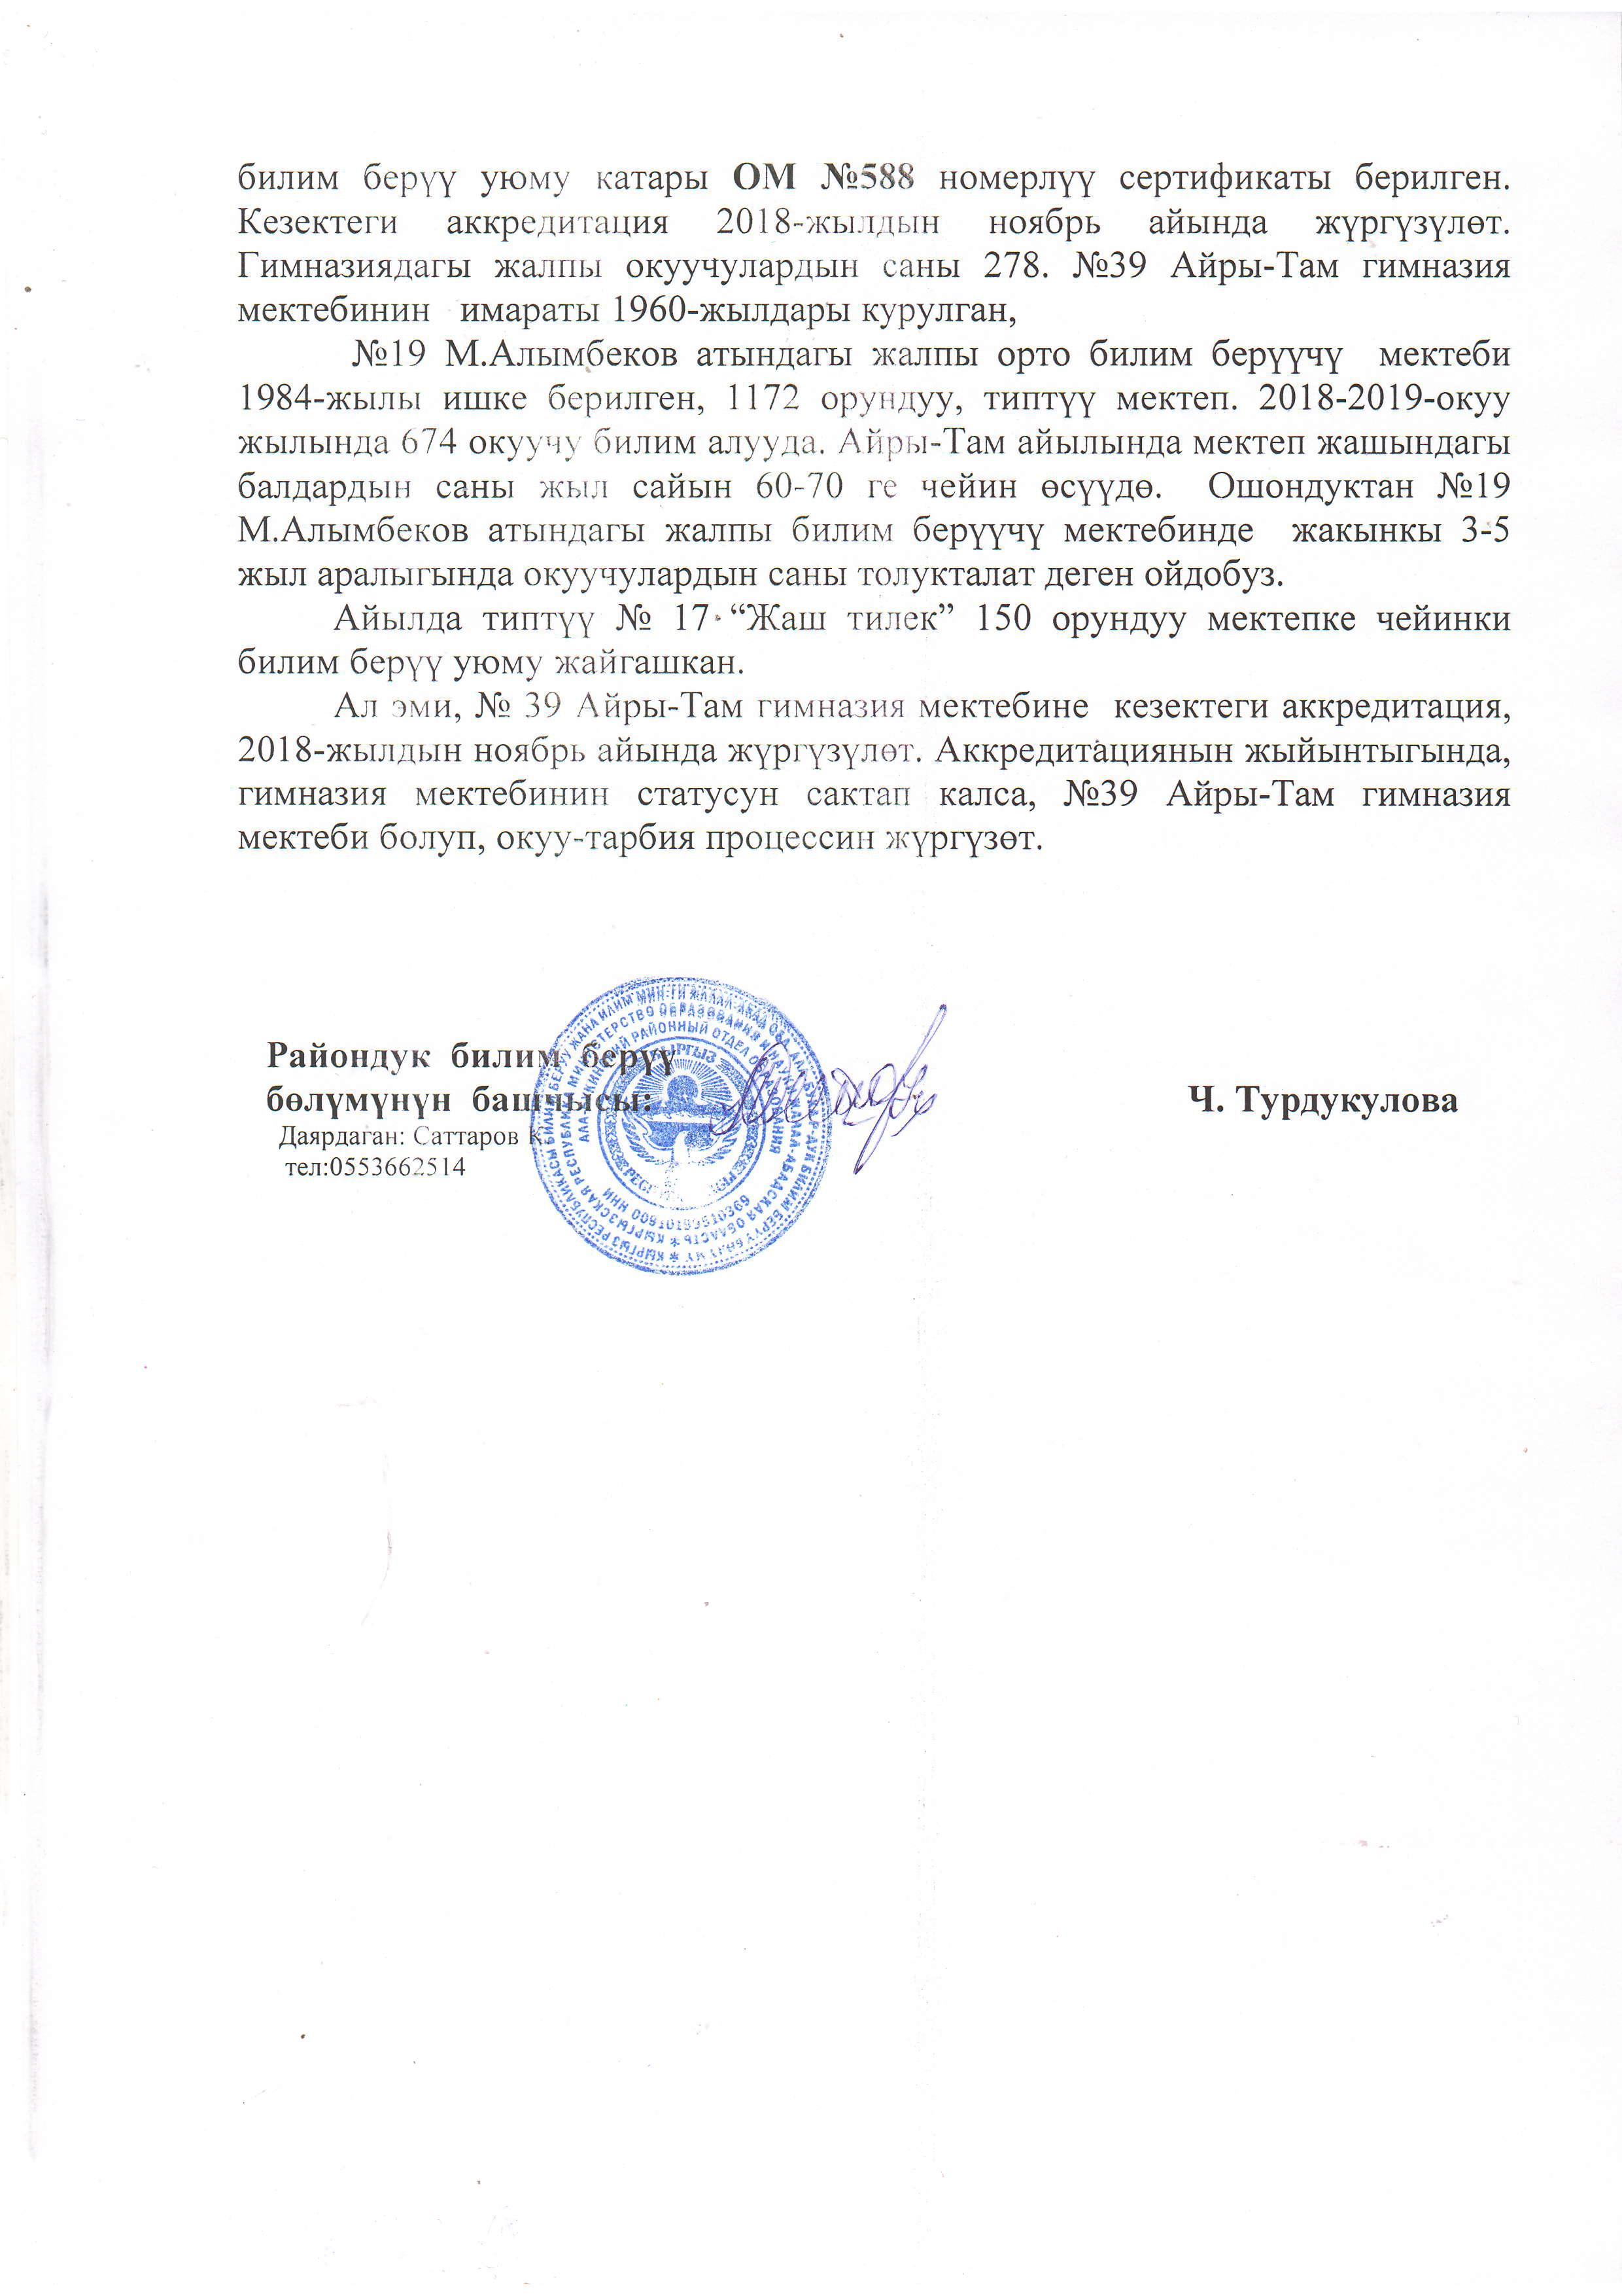6utruntr 6epyy yroMy Karapbr OM i\b588 HoMepnyy cepru$zxarrr 6epramen.

Kesexreru aKKpe/,ru4rLtL\ufl, 2018-xcr,r:rAbrH uor6pr afirruAa xypry3yner.

fuNaHasugAarbr )Karrrbr oKyyqynapAbrH carlbr 278. J\b39 Afiprr-Tarvr rr4MHa3n.rr

uerre6rauras LrMaparbr 1960-xunAapbr KypynraH,

J\b19 M.Anrrvr$exon arbrHAarbr )KaJIIrbr opro 6u:l,uw 6epyyry ueme6u

1984-xrusr r4rrrKe 6eparreu, ll72 opyrr/lyy, rr4rrryy MeKren. 20l8-2019-oxyy xbInbIHAa 674 oxyy'l)'Srllnu anyyila, A1ipr'r-Tavaftr,tlltHAa M9KTeII XaIUbIHAafbI

6an4ap4srn caHbr )Khrrr cafirru 60-70 r"e qeftuu oclyAo. Ourou4ynaH J\b19 M.Anuu6eKoB arbrHAarbr xaJrrrbr 1wltrrrNt Oepyyuy uerre6uH4e rxarrruxrr 3-5

x{brJr ap anbr rbrHAa o Kyyr{yr ap.qbrH c aHbrro Jr yKTan ar,{e reH ofi .qo6ys.

Afirula rznryy Nl l7"'XaurruJreK" 150 opyuAyy MeKrerrKe .{efizHrra

6utruwr 6epyy yroMy xafrraumau.

Ar ll,rl{, J\! 39 Afiprr-TaM rnMHa:Jr4.q MeKre6uue Ke3eKTeru aKKpeAr4Tarlkrfl, 2018-NruAbrH nox6pr, ailsuqa )Kyprpynor. AxxpeAurhquxuuu xrrrfirrHrbrrbrHAa, ruMHa3l4fl ntexre6nurau crarycyH caKTail KaJrca, J\|l39 Afiprr-Tavr rr4MHa3r4fl

verre6a 6oryn, oKyy-rap6zx npoqeccr4r-r )Kypry3or.

Pafion4y*c 6uru

6o.nynayHyH 6auf'$ {. TypayKyrroBa

,{arpaaraH: Carrapon

rer:05536625 14